**ANSIBLE INSTALLING METHODS**

Installing Ansible on Ubuntu

================REFERENCE THE VIDEO ===================https://www.youtube.com/watch?v=Km3BCQnV6sw&ab_channel=Intellipaat

sudo apt update

sudo apt install software-properties-common

sudo add-apt-repository --yes --update ppa:ansible/ansible

sudo apt install ansible

on hosts

==========

sudo apt update

sudo apt install python

===================================================================================

Step 1:

[**Installing Ansible on Ubuntu**](https://docs.ansible.com/ansible/latest/installation_guide/intro_installation.html#id24)

sudo apt update

sudo apt install software-properties-common

sudo add-apt-repository --yes --update ppa:ansible/ansible

sudo apt install ansible

Output

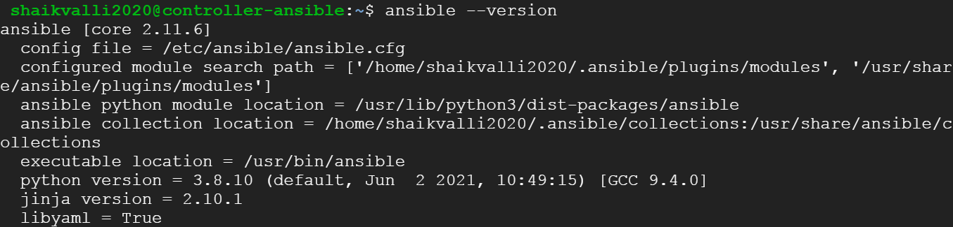

Step 2:

* + Now let’s try to install python on the node 1. Python is already installed 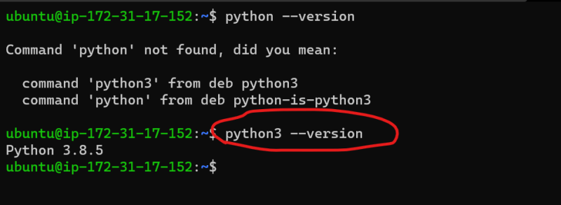
  + In AWS instances, the password is disabled by default. So lets enable password based authentication on both ansible control node and node1
    - In the /etc/ssh/sshd_config lets set the value of PasswordAuthentication
    - yes 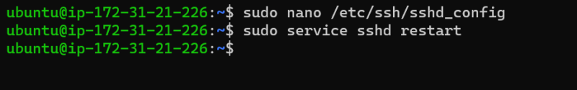
  + Then we would create an ansible user which simulates it admin on both the machines.
    - Log in to nodes and execute

sudo adduser ansible

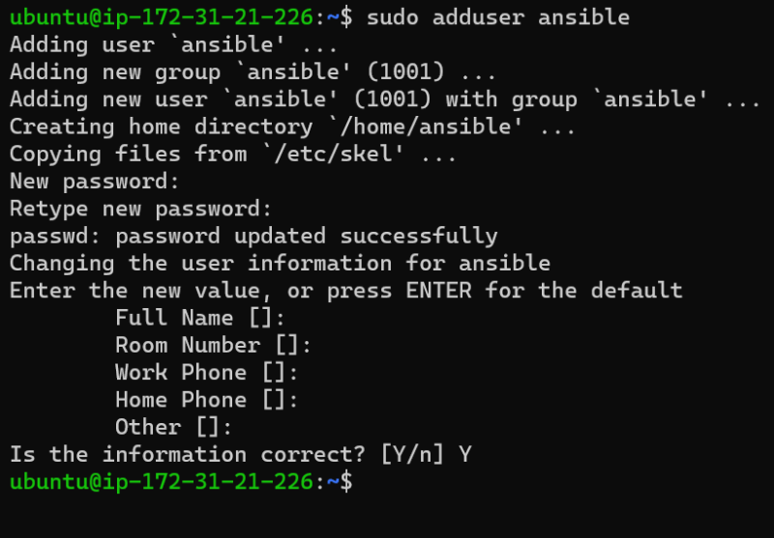

* + Now we need to give ansible user sudo privileges without prompting for password.

sudo visudo

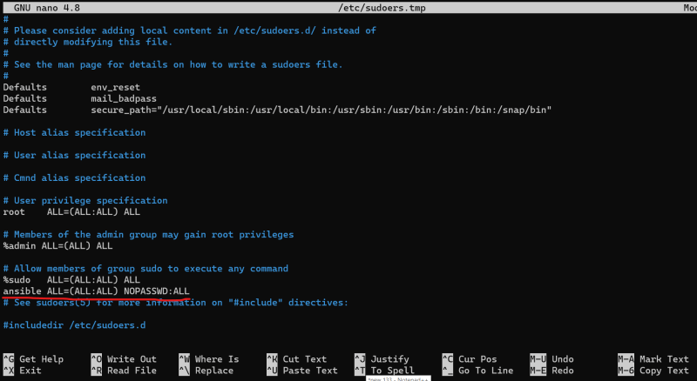

* Now entering password every time might not be good option for automating deployments, so let’s try to use key based authentication
* To Create a key based authentication b/w ansible control node and nodes
  + Create a key pair in Ansible control node
* ssh-keygen

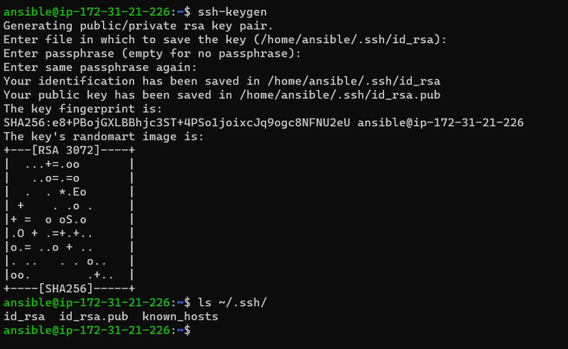

* + Copy the public key to the node(s) from ansible control node

ssh-copy-id <username>@<ipaddress>

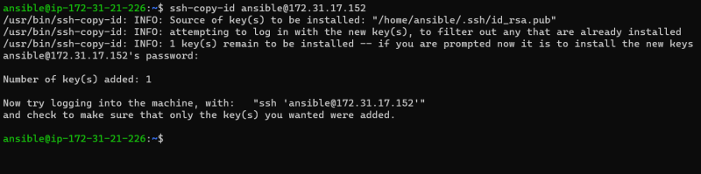

* + Now let’s try to login from ansible control node to node just by using ip address 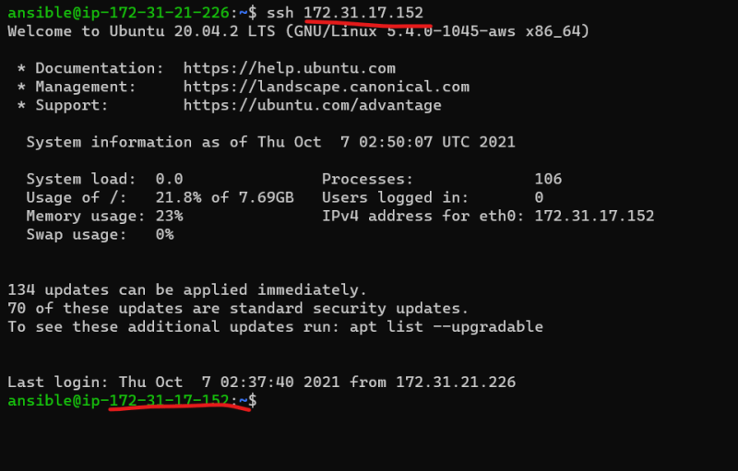
* Now lets try to ansible connectivity check without ask password

ansible -i hosts -m ping all

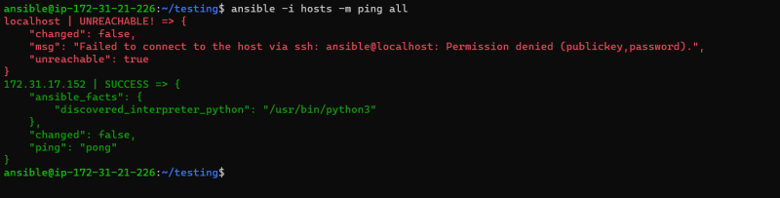

Now let’s try to copy keys to localhost

Step 3:

Now let’s go to particular path /etc/ansible/hosts

[Ansible@192.168.0.11$](mailto:Ansible@192.168.0.11$) sudo nano /etc/ansible/hosts

Go and last line and write the below details

[Production]

Slave1 ansible_ssh_host= 34.93.235.2 <node private ip address>

Step -4

Ansible –m ping all

Ansible –m ping production

Output

Success full data.

Success full access